Website Development

HTML and CSS Exercise

Create files labeled css1.html and css1.css to provide the formatting to turn this ordinary website:
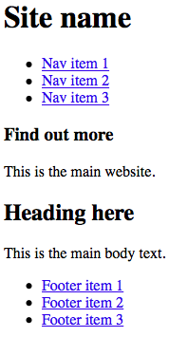
Into this formatted website:
